----- Original Message -----
From: HeadOfDept@ami
To: participant3@ami
Sent: Monday, December 06, 2004 2:34 PM
Subject: Please summarise the last meeting

Dear Colleague,

Would you be so kind to report to me on the past meeting? Please keep in mind that your notes are part of the project documentation – among other things, they will be used by myself and other staff to stay informed about the state of the project. It is therefore essential that your notes – though kept short - are of high quality. In particular:

- Do not use any abbreviations.
- Write notes that are understandable for somebody who was not present during the meeting

The head of your department

[ABSTRACT]
Current remote controller problems are:
- Too many buttons
- They are inconsistent
- Remote controller lost in the room
- It takes too much time to learn the user-interface
- Most buttons are not used

Some creative ideas found:
- Voice recognition
- LCD display
- Scroll buttons
- Controllers for special users: child-friendly design
- Protective covers to hide special functions
- Fancy look
- Simplicity is the key!

An example of a good prototype:
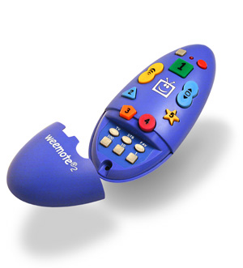

[DECISIONS]
- Use speech recognize technology
- Navigate on TV screen
- Pre-filter users’ preference by program
- Having the TV connected to the Internet to access XML plus some preprocessing
- KIV: LCD

Decisions: keep the navigation buttons only!

