----- Original Message -----
From: HeadOfDept@ami
To: participant3@ami
Sent: Monday, December 06, 2004 12:19 PM
Subject: Please summarise the last meeting

Dear Colleague,

Would you be so kind to report to me on the past meeting? Please keep in mind that your notes are part of the project documentation – among other things, they will be used by myself and other staff to stay informed about the state of the project. It is therefore essential that your notes – though kept short - are of high quality. In particular:

- Do not use any abbreviations.
- Write notes that are understandable for somebody who was not present during the meeting

The head of your department

[ABSTRACT] In the last meeting, the functional design aspect was discussed in details. As for my part, I found the following information: The function of a remote control is basically to send messages to the television set. Example messages are: "switch on", "switch off", "switch to next channel", "switch to channel 9", "turn volume up", etc. The followings are two examples of a remote control interface through which the functions are fulfilled. Here are two prototypes from the competitors:

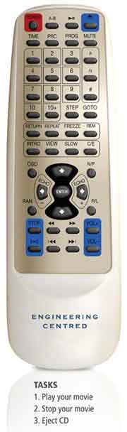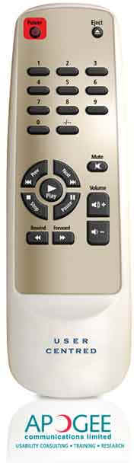

[DECISIONS]
Proposals:
- Easy
- Navigate on TV screen
- Pre-filter users’ preference by program
- Having the TV connected to the Internet to access XML plus some preprocessing
- KIV: speech recognition

Decisions: keep the navigation buttons only!

